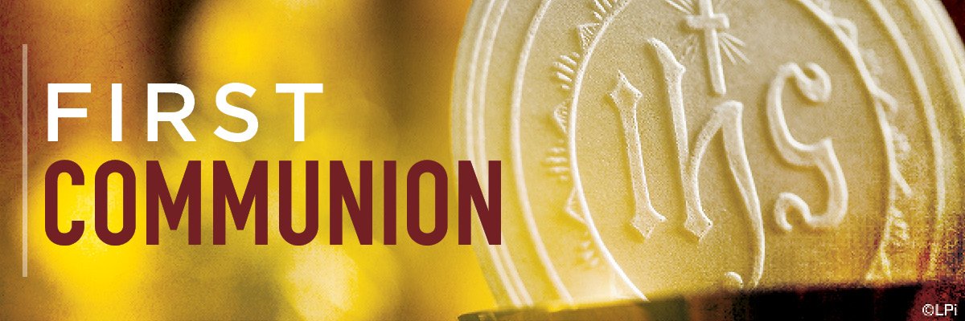
Sacramental Preparation for First Holy Communion Calendar
Wednesdays – 4 p.m. – 5 p.m.
Led by Rachael Dickson & Becky Clark

January 31, 2024
February 7, 2024
February 21, 2024
March 13, 2024
March 27, 2024
April 10, 2024
April 24, 2024

First Communion Retreat: Saturday, April 13th – 9 a.m. to Noon on Campus
First Communion Mass: Sunday, May 5th at 11 a.m.

